

TECHNICAL UNIVERSITY OF KENYA
FACULTY OF APPLIED SCIENCES AND TECHNOLOGY
SCHOOL OF COMPUTING & INFORMATION TECHNOLOGY
END OF SEMESTER OCTOBER 2017 EXAMINATION SERIES
THIRD SEMESTER EXAMINATIONS 2016/2017
THIRD YEAR EXAMINATIONS FOR THE DEGREE OF
BACHELOR OF TECHNOLOGY IN INFORMATION TECHNOLOGY
ECII 2203 : ELECTRONIC COMMERCE
TIME: 2 Hours OCTOBER 2017

Instructions to candidates:
This paper consists of FIVE Questions.
Answer Question ONE [30 Marks] and any other TWO Questions [20 Marks Each].
Write your college number on the answer sheet.
This paper consists of 3 printed pages
Candidates should check the question paper to ascertain that all the pages are printed as indicated and that no questions are missing.
© October 2017 The technical University of Kenya Examinations

QUESTION ONE (30 MARKS) COMPUSORY
- Define personalization and user profile as used in E-Commerce (2marks)
- Outline the major limitations of online market research (2 Marks)
- Briefly elaborate on the strategic advantages of Electronic Auctions (5marks)
- Identify any THREE possible security risks to a customer transacting on an E-Commerce website and explain how to effectively deal with them (6 Marks)
- (i) How are bitcoins different from other electronic payments modes? (2 Marks)
(ii)Most people believe that bitcon transactions to be untraceable and insecure. Discuss (3Marks)
- Describe the factors that are critical for an e-payment method to achieve critical mass (4marks)
- EC applications can be developed through several alternative approaches. Discuss any three of these approaches (6Marks)

QUESTION TWO (20MARKS)
- Using relevant examples, differentiate between E-Store Fronts and E-Mall (2 Marks)
- World Wide Web has changed the whole scenario of business." Comment on this statement (4 Marks)
- Provide a brief overview of legal and ethical issues in Electronic Commerce (6 Marks)
- Identify and justify the appropriate revenue model(s) for E-Commerce firms engaged in the following types of business.
- Social networks (1 Marks)
- Premium content (1 Marks)
- Steering business to other firms (1 Marks)
- Discuss in details the different types of Electronic payment system (5Marks)

QUESTION THREE (20MARKS)
- The emergence of the web and growth of ecommerce and e-business have forced enterprises to move away from private communication networks to public networks. This brings with it new problems and security threats that companies needs to deal with. “ e-finance.com” is a financial company offering a variety of services to both private and public customers. Naturally security and the safety of data and transactions are of paramount importance to the company. For application security requirements, using appropriate examples, discuss your understanding of following issues

- Authentication
- Authorization
- Message Integrity
- Confidentiality (8 marks)
- Discuss the phases in website development cycle stating the outcome in each and every phase (6 marks)
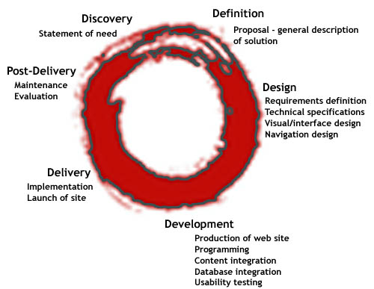
- Define the various types of testing used during the EC development process (4Marks)
- Outline any two benefits of EDI (2Marks)
QUESTION FOUR (20MARKS)
- Discuss any five technical and non technical attacks that are imposed on E-Commerce (5marks)
- Discuss any five criteria’s for selecting a development approach (10Marks)
- Discuss any five components of a well functioning commercial website (5 Marks)
QUESTION FIVE (20MARKS)
- Outline the basic elements of a multitiered application architecture. (2Marks)

- Using a diagram discuss how selecting an EC application vendor and package is done (10Marks)
- Briefly elaborate on the strategic advantages of Electronic Auctions (3 Marks)
- Explain how a company can minimize and safeguard exposure to risk on criminal and civil charges (5marks)

